Birla Institute of Technology & Science, Pilani
Work-Integrated Learning Programmes Division
First Semester 2022-2023
End-Semester Test (EC-3 Regular)
Course No. : BAZC420/SEZC420
Course Title : DATA VISUALIZATION & INTERPRETATION
Nature of Exam : Open Book
Weightage : 40%
Duration :
Date of Exam :
Note:
- Please follow all the Instructions to Candidates given on the cover page of the answer book.
- All parts of a question should be answered consecutively. Each answer should start from a fresh page.
- Assumptions made if any, should be stated clearly at the beginning of your answer.

1 | A survey was conducted to measure the student’s interest in different data science courses offered by BITS. Students had three options for each topic: Very Interested, Somewhat interested, and Not interested. Around 2200 students completed the survey. If you examine the csv file, you will find that the first column represents the course names and the first row represents the choices for each course.  The result of the survey is presented as a visualization below. Recreate the same to the finest details. [The color codes are 'mediumturquoise', 'limegreen','firebrick' respectively] Clearly mention the steps and the python code for each step.  Assume and clearly mention the assumptions made for anything that is not visible clearly in the below image.  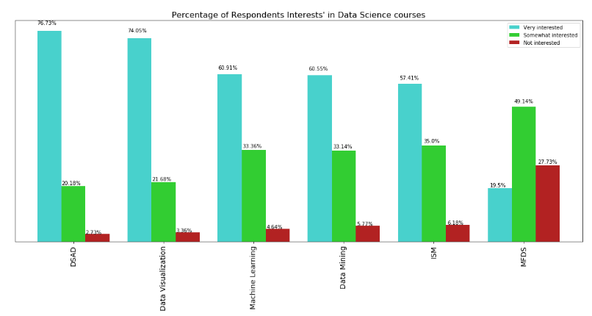 | 10M
   | Very interested | Somewhat interested | Not interested
  Data Mining | 1332 | 729 | 127
  DSAD | 1688 | 444 | 60
  MFDS | 429 | 1081 | 610
  Machine Learning | 1340 | 734 | 102
  ISM | 1263 | 770 | 136
  Data Visualization | 1629 | 477 | 74
2 | Assume that you work for a pharmaceutical company. You focus on Product X, a medication for Alice in Wonderland syndrome (Yes! It is real!).You have to now provide an update on Product X’s penetration in the marketplace. Think from the company perspective and provide a useful explanatory visualisation for them.  Points: This disease doesn’t affect everyone equally. Rather, diagnoses tend to be classified by severity into Mild, Moderate, and Severe.  Present the single slide visual and briefly explain the design choices made.  Data you have is  - Choice of chart type, Decluttering, Effective use of Gestalt principles, Strategic use of pre-attentive attributes, Logical ordering and effective use of text, whitespace -contribute towards the credit.  - Most effective chart fetches maximum credit.  - Visual without explanation fetches no credit.  - [Pen and paper drawing would suffice. No additional credit for usage of any Viz Tools for creating visuals] | 5M
   | % OF TOTAL |  | NUMBER OF PATIENTS
   | Patients diagnosed  N = 4,363 | Patients taking Product X  N = 1,861 | Patients diagnosed | Patients taking Product X
  Mild | 33% | 17% | 1423 | 322
  Moderate | 47% | 66% | 2042 | 1247
  Severe | 21% | 17% | 898 | 312
  Total | 100% | 100% | 4363 | 1881
3 | Redesign the visual, without information loss, with appropriate choice of display medium/s to communicate the below point also effectively.  “Anything above 15mins of delay is considered critical”.  Use reference lines and pre attentive attributes appropriately.  - Present only the final version of the graph/s [2M].  Declutter wherever necessary.  - List down the proposed changes and the reasons. [2M]  Most effective chart fetches maximum credit.  [Pen and paper drawing would suffice. No additional credit for usage of any Viz Tools for creating visuals]  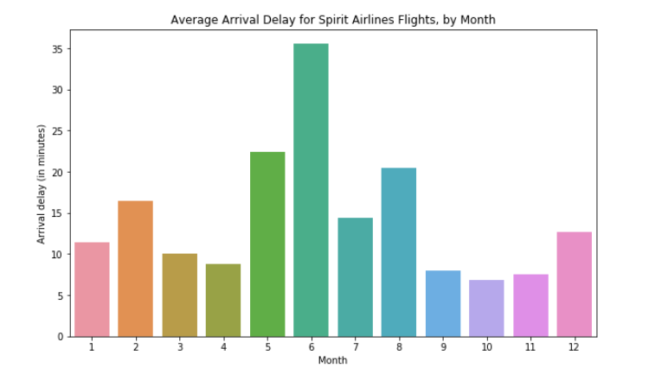 | 5M
4 | You have been assigned a project to design a dashboard for a retail company, Fashion Forward, which aims to consolidate and visually represent data from various sources to facilitate data-driven decision-making. Consider the requirements and challenges mentioned in the problem statement.  - Identify three key performance indicators (KPIs) that would be crucial for Fashion Forward's management team to monitor on the dashboard. Explain your reasoning for selecting these KPIs.  - Describe the process you would follow to design the dashboard, including data sourcing and integration, selection of appropriate visualization techniques, and customization options to cater to different user needs and devices.  - Provide a detailed sketch or mockup of the proposed dashboard design, including the layout, visual elements, and interactivity features. Explain how your design addresses the specific needs and challenges of Fashion Forward's management team.  - Discuss how your dashboard design ensures accessibility, responsiveness, and user-friendliness across various platforms and devices. Also, explain any potential limitations or challenges that you may encounter during the design and implementation process. | 12M
5 | Assume you have a data frame with following columns and data types  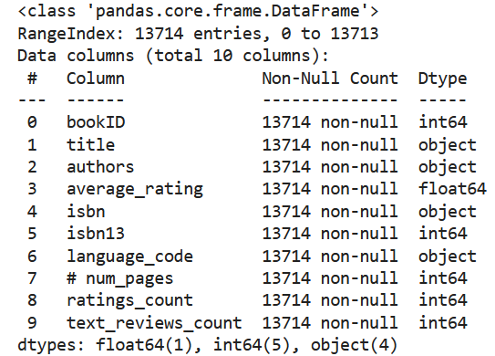  Write python and seaborn code to analyse and visualize following.  (Your code should give following visuals to the nearest details.  Clearly mention any assumptions or data pre-processing done on the data so that you code can plot below visuals)  - Top 10 most rated books  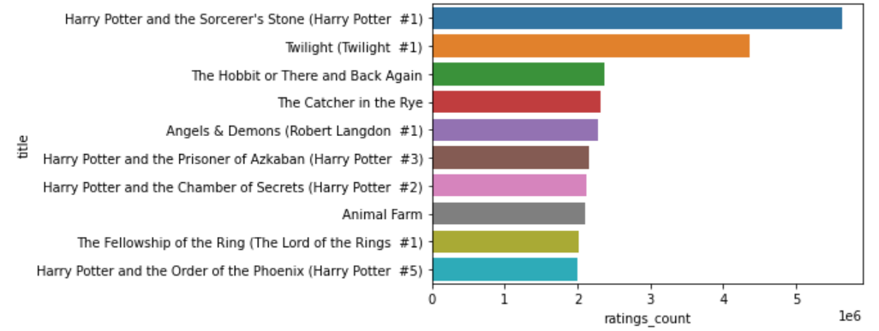  - Top 10 authors with the greatest number of books published  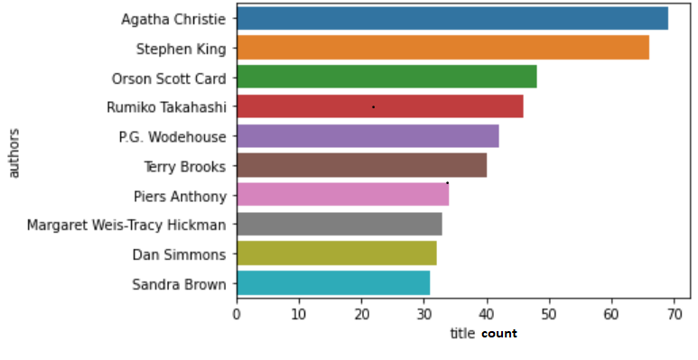 | 8M

